Atitit.获取swing ui 按钮控件的id 与名字

# Eclipse vm param

-agentpath:E:\swing-inspector-windows-1.2.2_beta7\Win32\swing-inspector-agent.dll

# Cltr+f12显示主界面

# Ctrl+鼠标找到控件

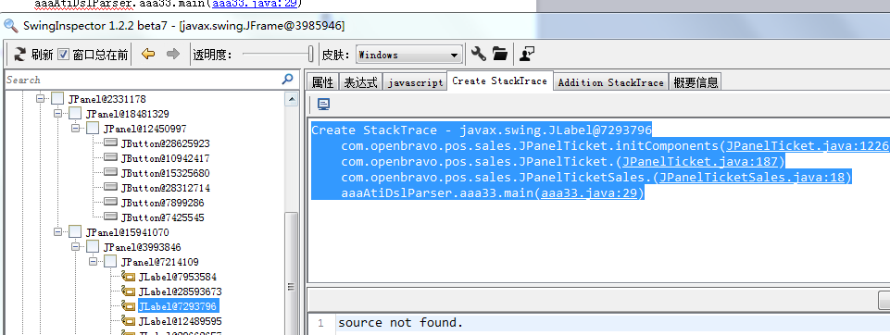

Create StackTrace - javax.swing.JLabel@7293796  
    com.openbravo.pos.sales.JPanelTicket.initComponents([JPanelTicket.java:1226](com/openbravo/pos/sales/JPanelTicket.java:1226))  
    com.openbravo.pos.sales.JPanelTicket.([JPanelTicket.java:187](com/openbravo/pos/sales/JPanelTicket.java:187))  
    com.openbravo.pos.sales.JPanelTicketSales.([JPanelTicketSales.java:18](com/openbravo/pos/sales/JPanelTicketSales.java:18))  
    aaaAtiDslParser.aaa33.main([aaa33.java:29](aaaAtiDslParser/aaa33.java:29))

# 找到源码

**this**.m_jTotalEuros = **new** JLabel();

**this**.m_jLblTotalEuros1 = **new** JLabel();

**this**.m_jSubtotalEuros = **new** JLabel();